All-Software based USB low-speed host
and ImGui graphical demo for LiteX

This is an implementation of a 100% software USB host stack for a LiteX SoC, and a GUI demo based on Dear ImGui library both running on the same CPU. It currently supports the Digilent Arty A7 board implementing a VexRiscv soft-core CPU running at 166/200MHz, and low-speed mouse and keyboards.

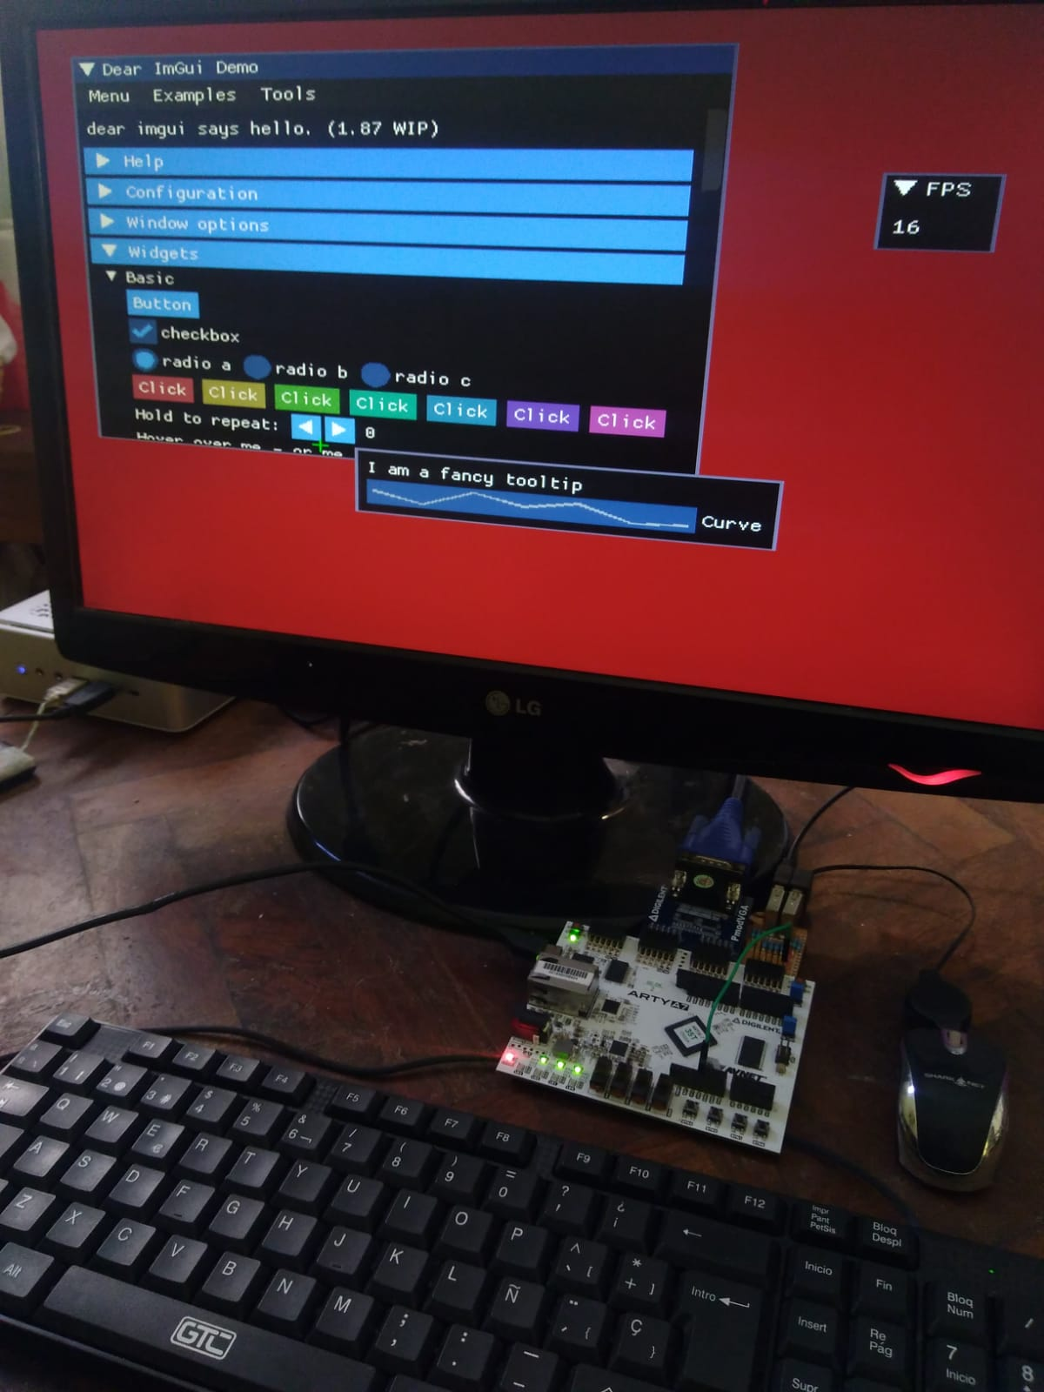
Features:
- 100% software implementation (GPIO)
- Four simultaneous HID devices with protocol decoders for mouse and keyboard
- 800x600 24-bit color Digital video (DVI) or 640x480 12-bit color analog VGA
- Optimized software renderer for ImGUI, up to 60 FPS (sliders + text input demo)
- Supports Framebuffer write with DMA at 32 bit or faster 64-bit mixed DMA/software
- Multi-target (FPGA or microcontrollers)
- Allows mixed C and C++ code with mixed LTO (link time optimizations)
- Capable of running single-core, and multiple frequencies supported
- FPU recommended but not required
- Special memory sections to run fast code or to access fast block RAM
- Dynamic memory allocation (malloc/new)
- UI runnable on a PC for rapid testing
- Hardware required is just 2 pulldown resistors and the USB connector
- Automatic mouse acceleration algorithm for natural operation
- Signals generation at 1.5mbps using delays or timing error compensation for each bit
Required HARDWARE

- a Digilent Arty A7 FPGA board
- a VGA PMOD on connectors B-C, or a DVI adapter on connector C
- a dual USB PMOD on connector D

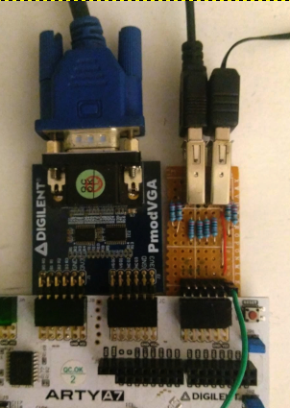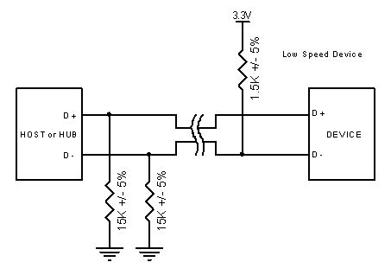

NOTE: The dual USB host PMOD has 15K pulldown resistors on data lines, and some small value (33ohm) series resistors to cope with any signal reflection. USB devices should be fed with an external 5V supply (not available on the PMOD connectors).

SOFTWARE PREREQUISITES

- LiteX and associated tools (compilers, synthesis tools, etc.)
- Risc-V soft float emulation library https://github.com/pulp-platform/RVfplib
- Other libraries used are already integrated or referenced as git sub-modules

Development design and decisions

USB Host stack
The selected host libary was one specific for ESP32 line of microcontrollers. The TinyUSB was evaluated too but it depends too much on harware suppport, while the ESP32 one was based just on GPIO. Unfortunately, the entire design assumed a fixed 240Mhz clock for the CPU and a dual core, plus the ESP32 specific peripherals. Also, FreeRTOS (common for ESP32 development) is used in the original library. So it was ported to abstract the platform, peripherals and clock frequencty.
Initially, the patform used as a test for migration was the Teensy 4.1 board, where the custom host was made to run. A was a to run the host stack and the main algorithms in a single CPU was added, using interrupt handling and queues (the latter ported from the TinyUSB library) and pooling of the queues on the main loop.
Since all the development is time-sensitive to match the USB low-speed spec (1.5MHz) there was a need to run some code from fast memory, as well as accessing a faster RAM that’s more deterministic than a DRAM.
In porting the code, GPIO, Timers and CPU clock access were abstracted, and current implementation uses the ones from LiteX’s C SDK, currently under development here:
The code was kept compatible to use original ESP32 implementation, if target is ESP32. Other supported target was the Teensy 4.1 platform, where it has been initially tested (latest code needs retest since the last versions are being tested just on the FPGA).
Timing functions were adapted to cut dependency on 240MHz clock, and supports various frequencies on Teensy and two options in LiteX, updating data types whenever needed (now, clock count can need more than 8 bits).
Code was adapted to not require C++ thus plain C compilation as in the other LiteX libraries.
FP emulation library was included since the library use them for some timing calculations at setup time.
A custom printf function was used and changed to fix an ABI issue related to alignment of doubles on the stack frame (printf’s variadic arguments)
A periodic Timer ISR was setup (1KHz as the USB specification) for packet handling, considering that the USB host commands the bus.
Additionally, two algorithms for timing calculations for sending the data bits are available: a relative one (waiting a constant amount) and a absolute one one that corrects for jitter and delays introduced at running the CPU code. Currently, as well as in the original ESP32 library, the pins used for USB hosts should be in bits 8 to 16.

Mouse and keyboard support
There’s also a basic decoding of packet to detect HID devices (mouse and keyboard). In the case of the mouse, the algorithms considers acceleration for natural operation and not updating the UI until after all queued movements are being processed. In the case of the keyboard, all 6 simultaneous keyboard pressesd are supported with the modifiers (CTRL, ALT, SHIFT, SUPER), left and right, and a characted decoding table is utilized (US layout) when modifers are none or SHIFT. Clipboard is supported too by using CTRL-X, CTRL-A for selecting all characters, etc. The UI is updated with any key pressed or released.

Video Output and rendering
The project suppors Digital video (DVI ) at 800x600 or Analog video (VGA) at 640x480.
For digital output, a PLL “trick” was done in order to avoid running out of outputs: the CPU clock is made to match the fast HDMI clock (5x the pixel clock with DDR outputs)
The ImGui is configured with correct color channel allocations by using the following macro: IMGUI_USE_BGRA_PACKED_COLOR.

A “simulator” is also included (make sim target) that compiles de UI code and runs it in a Linux box using the SDL library. This is to test the UI before compiling the sources to be run in the FPGA CPU softcore, saving in compilation timing. The other advantage of having a Linux target is to test the software renderer, once the code is updated with the feature to use the software renderer to generate the framebuffer data. Currently, the UI uses just a OpenGL target (the ImGui project is originally designed just for GPUs).

The following capture shows the same UI rendered in OpenGL in a window in the develping machine alongside a picture of the monitor when the UI runs in the FPGA with an attached monitor.

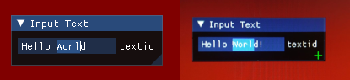

DMA access to the framebuffer

For drawing primitives, the framebuffer can be accesed by the CPU or, in a faster way, using DMA cores. They allows two bus configurations: 32-bit and 64-bit one. In the first case, each word corresponds to a pixel so there’s no issues with alignmement, but’s not as fast as using 64-bit, in which case the misaligned pixels appearing hotizontal at the start and/or end, are accessed byt the CPU. The algoirithm is also cache-aware, so the alignment used is not only 64-bit but the cache line size. This allows to cope with pixel data that’s not reflected in the cache if previously accessed by DMA.
In the following picture, the CPU accesed pixels needed for mialignemnt corrections are painted in red:

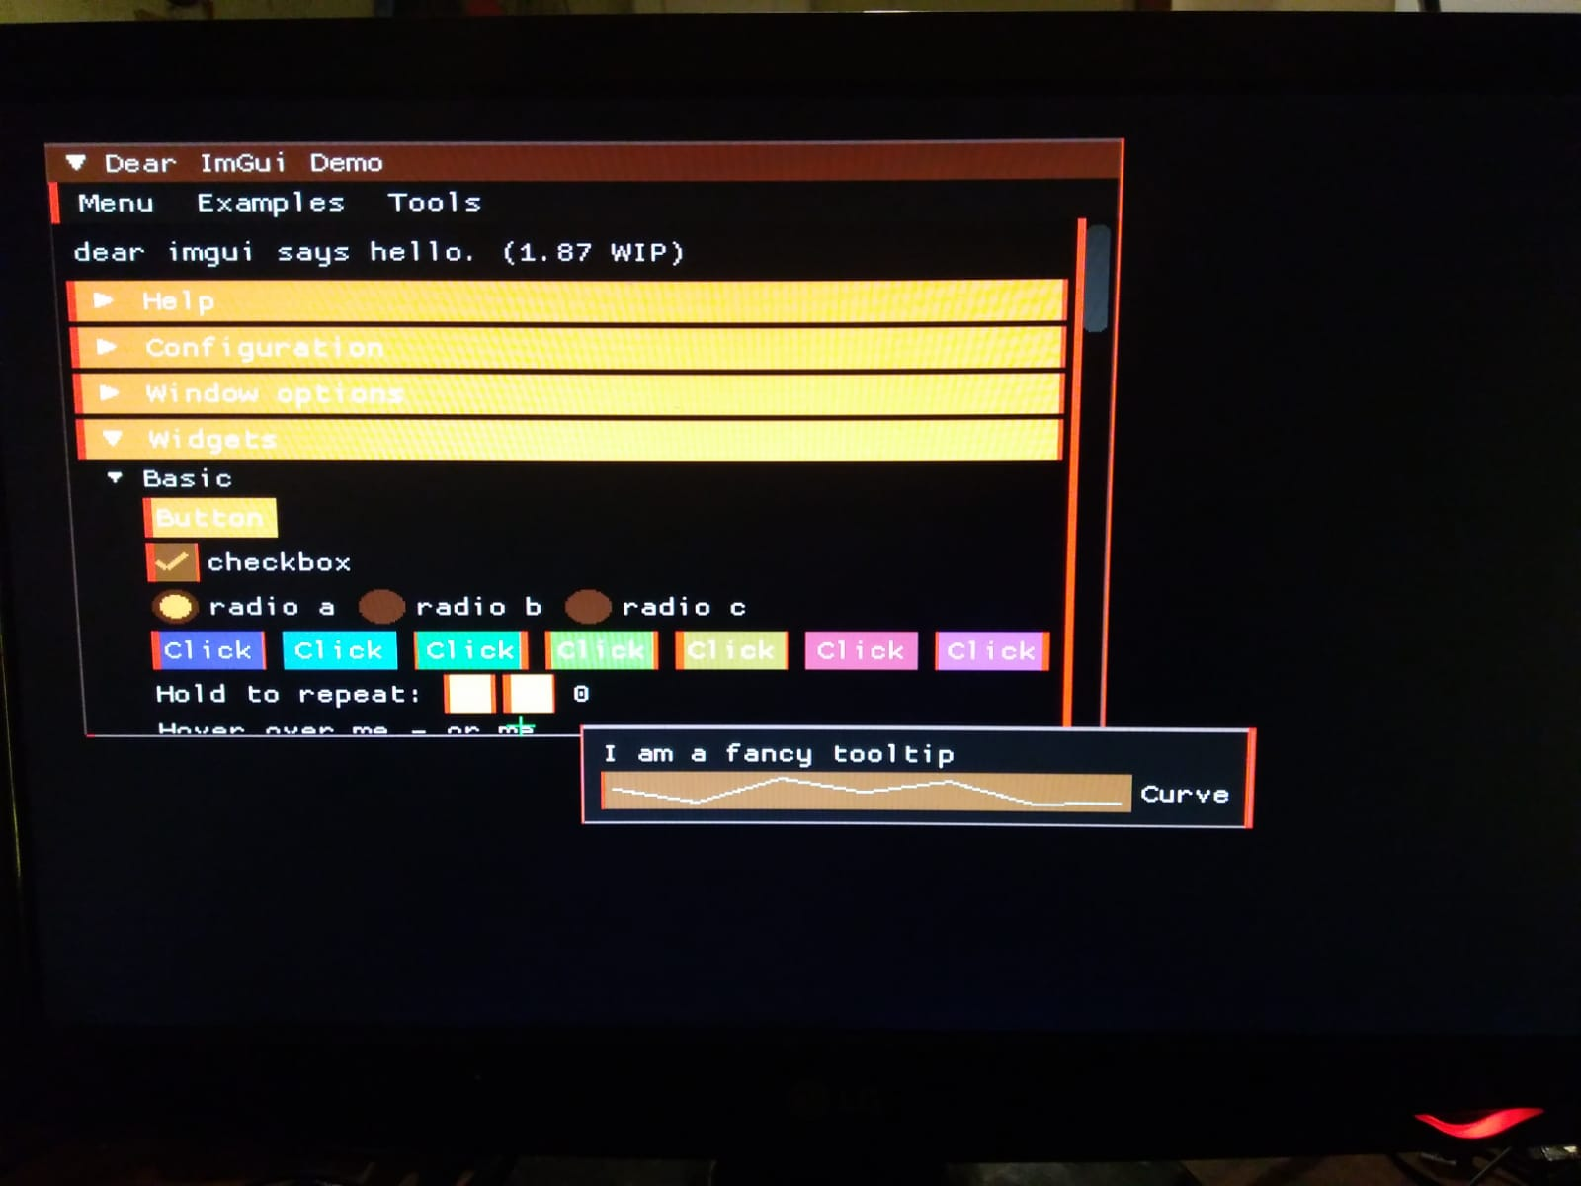

As can be seen, the CPU access is minimal.

Software-only rendering

The ImGui library supports many video output target (and corresponding “renderer”) but it basically assumes the presence of a GPU capable of various types of shading for triangle meshes. In the current project, a public-domain software renderer is used based on a open-source project by Emil Ernerfeldt: https://github.com/emilk/imgui_software_renderer

The renderer was initially modified to get some acceleration to draw boxes of solid colors by Bruno Levy, then modified for this project to include solid triangles rendering and an optimized bitmap blitter used for font rendering. That way the resulting accelleration was about 3X so able to run the “canonical” demo ImGui at a usable speed (16FPS main window with showing some basic widgets) and the main demo of this projects using sliders and an input box, at 60FPS:

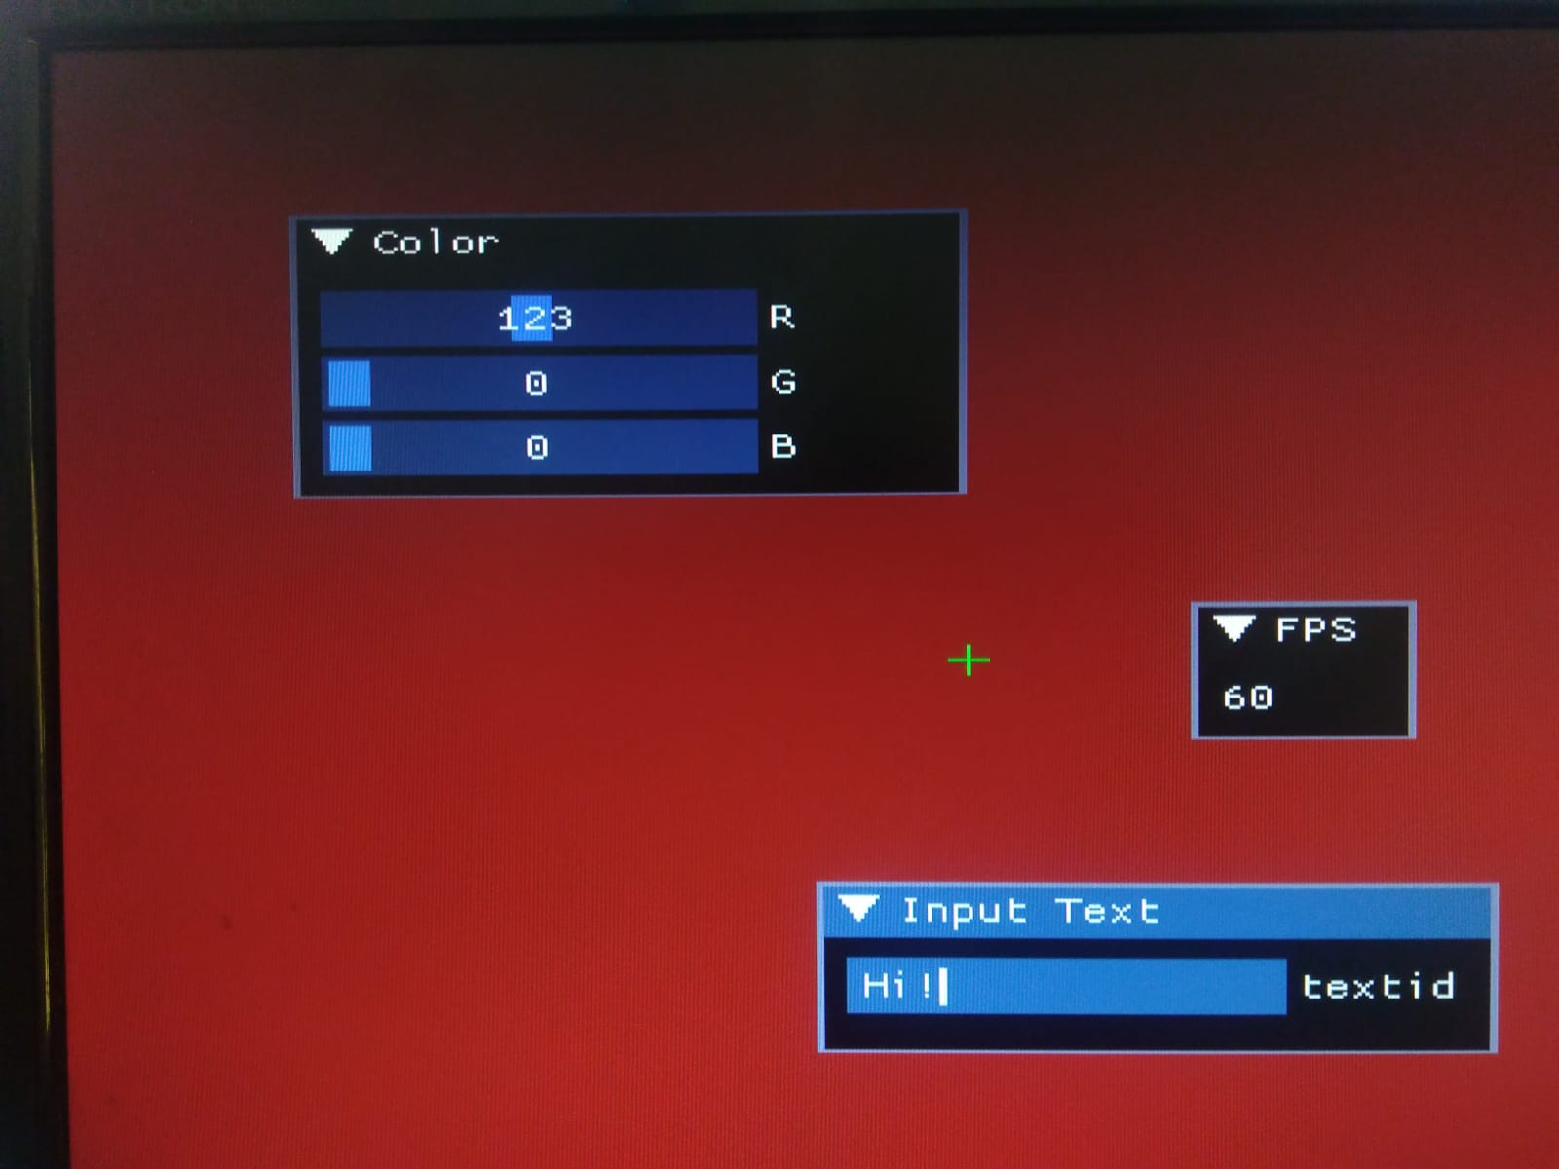
Compilation flags

Since C and C++ sources are mixed, they should be compiled with the same ABI, and a soft CPU with no FPU is used. So the demo sources, the LiteX base sources (such as uart.c) and the soft FP library should have matching compiler flags:
-march=rv32im -mabi=ilp32

Execute from SRAM (block RAM) and put data on SRAM
The LiteX’s C SDK provides macros to put selected code and data in sections that goes to SRAM. The linker scripts defines that sections to go to SRAM (automatically using the SRAM/SDRAM address autogenerated by LiteX), and the startup files (crt0.S) copies initial values from slower memory to SRAM

#define FAST_DATA __attribute__ ((section (".fast_data")))
#define FAST_CODE __attribute__ ((section (".fast_text")))

Example of use:
static int FAST_DATA value = 3;
void FAST_CODE square() { return value*value; } //this is run in SRAM

The feature is used in USB code that needs to be run as fast as possible that are too slow if running from SDRAM. The fast sections are also used in the interrupt handler, and to manage the queues used by the usb host code. Indeed, currently all usb host functions and relevant data structures plus the USB queues are set this way, but if there’s no enough space in block RAM, there’s in the commit history a selection of the minimal set of functions and data structures that needs to be set as fast.

Linker and startup files

Project is linked with link-time optimizations (LTO) set, that way it can mix LTO code and non-LTO code in same binary. LTO is needed for some code to run fast but some code needs to be non-LTO since the compiler mangles the corresponding sections disalowing correct filters on the linker script.

The crt0.S file defines a IRQ handler that saves/restore regiters, that calls the isr_handler C function, currently managin UART and TIMER0 interrupts. Also it initializes data on SDRAM or and copying portions to SRAM from SDRAM where binary is initially loaded, using the code or data sections .fast_data/.fast_text. (NOTE: this could be handled in C to ease the code)

The linker script defines the extra sections and now correctly handles code that has or has the link-time optimization (.gnu.*lto* sections), providing variables with addresses to be read in startup code (assembly or C).

Custom printf
The project provides a custom printf with a bufix for handling floating point values aligmnent uses (double types, as such variadic functions assume and convert). The other printf-like functions as provided by the starndard C library cannot handle float values, this is a pending feature to be added so ImGui is capable of displaying float values in widgets.

Dynamic memory
the project uses the linker script variable _end correcty set for allowing the _sbrk function to be used by malloc/free functions. Also, there are overloaded new and delete operators to be used by C++ and associated custom allocation functions for ImGui, that allocates about 160KB of SDRAM at startup.

Analog video fix
To avoid unwanted color distortions with analog video output, a patch was done as reported in https://github.com/enjoy-digital/litex/issues/1349

for i in range(cbits):
self.specials += SDROutput(i=sink.r[cshift + i] & sink.de, o=pads.r[i], clk=ClockSignal(clock_domain))
self.specials += SDROutput(i=sink.g[cshift + i] & sink.de, o=pads.g[i], clk=ClockSignal(clock_domain))
self.specials += SDROutput(i=sink.b[cshift + i] & sink.de, o=pads.b[i], clk=ClockSignal(clock_domain))

BUILDING

Build RISC-V FP Emulation library:

It's assumed you will use a folder with this and other repos, referenced as $REPOS_ROOT (so this project gets in $REPOS_ROOT/litex_imgui_usb_demo)

cd $REPOS_ROOT
git clone https://github.com/pulp-platform/RVfplib
cd Rvfplib

Tweak makefile:
CC := riscv64-unknown-elf-gcc
CCFLAGS := -march=rv32im -mabi=ilp32
OBJDUMP := riscv64-unknown-elf-objdump

run make

Commands to run for generating the SoC with LiteX

It's assumed that LiteX is downloaded and compilers correctly set
To generate the bitstream, tweak the .py file and run one of the following commands:

1) cd $REPOS_ROOT/litex_imgui_usb_demo

2) check DVI = False in digilent_arty.py

3) run ./digilent_arty.py --timer-uptime --uart-baudrate=1000000 --with-pmod-gpio --integrated-sram-size 32768 --sys-clk-freq=200e6 --cpu-variant=full --build

There’s a digital video output option at 800x600 instead of analog VGA at 640x480 (the CPU runs 166Mhz instead of 200Mhz)

set DVI = True
run ./digilent_arty.py --timer-uptime --uart-baudrate=1000000 --with-pmod-gpio --integrated-sram-size 32768 --sys-clk-freq=166666666 --cpu-type=vexriscv --cpu-variant=full --build

4) to load, run openFPGALoader -b arty build/digilent_arty/gateware/digilent_arty.bit

at first load a screen should appear showing RAM garbage

Building the demo

cd src
run make clean all
run litex_term --speed 1000000 --kernel usb_main.elf.bin /dev/ttyUSB1

NOTE: update the USB device to match your OS. The LiteX generated bitstream may need to be reloaded

Related open source software

The following list includes software that integrates the demo, related repos (with detailed commit history), and location of sources (assumes . = $REPOS_ROOT/litex_imgui_usb_demo/). They were modified to suit the needs of this project.

- ESP32 USB host: https://github.com/suarezvictor/ESP32-USB-Soft-Host/tree/main/src → ./Libs/usbhost
- TinyUSB: https://github.com/suarezvictor/tinyusb/tree/master/src → ./Libs/tinyusb
- ImGUI (v1.87 WIP): https://github.com/ocornut/imgui/tree/78b28d545f79c5c5ed3e0ebae4099e44bdc6c5a6→ ./Libs/imgui (includes https://github.com/emilk/imgui_software_renderer and minimal tweaks from learn-fpga project)
- Printf library: https://github.com/mpaland/printf -> ./src
- LiteX’s C DK: https://github.com/suarezvictor/litex_sdk → ./Libs/litex_sdk
- digilent_arty.py from LiteX boards https://github.com/litex-hub/litex-boards/blob/master/litex_boards/targets/digilent_arty.py → ./

